Methodology

For all the analysis of the spread, we chose to begin our training and testing period at the beginning of the master dataset (10/19/2021). We knew that we wanted to remove all observations before the bubble because we identified that the fast-paced evolution of the NBA would cause prior data to not be as accurate for predicting the style and officiating of today's game. Stats from the deadball area, for example, could cause systematic low spread values because of the slower pace of play and totals from then. We decided on a simple 80/20 chronological split for simplicity and to maintain the element of predicting for the future that the final predictions would require.

The naive baseline that we used as a baseline was the average margin for the home team subtracted by the average margin of the away team divided by 2. We chose this approach as a way to simply estimate team strengths and give us an error value to work towards improving. Analysis of this naive method across the selected time frame resulted in an MAE of 12.436.

The base features that we ultimately selected were elo_diff, netrating_diff, offRating_diff, defRating_diff, pace_diff, diff_last5_margin, rest_diff, and home_indicator. We felt that this would give us a good baseline of relative team strength, recent form, and scheduling factors like location and fatigue from little rest. Additionally, pace was included as teams that play faster will exaggerate their advantage or disadvantage in the final spread through more possessions. We ran a linear regression with those eight base features with the same 80/20 split and got a test MAE of 11.7605.

For feature selection, we decided to use a lasso-based regularization and to run an alpha sweep to help us evaluate the relationship between test_mae and the number of kept variables, as well as variable coefficients. The alpha sweep resulted in the results pictured, and after trying 0.05, we landed on that as it kept the same 7 variables as alpha of 0.10 with a small but measurable gain in test MAE.

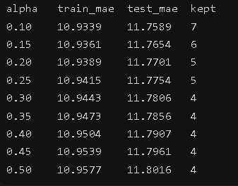

The results from the lasso regression with an alpha of 0.05 was a test MAE of 11.7517 with the following 7 features:

- netrating_diff = 0.3072
- diff_last5_margin = 0.0804
- defRating_diff = -0.0264
- pace_diff = -0.0246
- elo_diff = 0.0212
- rest_diff = 0.0135
Dropping offRating_diff - We felt that all features being tested were highly relevant, so only having 1 dropped was reasonable.

Best Model

